TCP Reno Congestion Control Simulation
Name: Manish Kumar
Roll No: 2503B09903

Simulation Results

Loss Probability: 0.001
Throughput: 1109.700 MSS/second
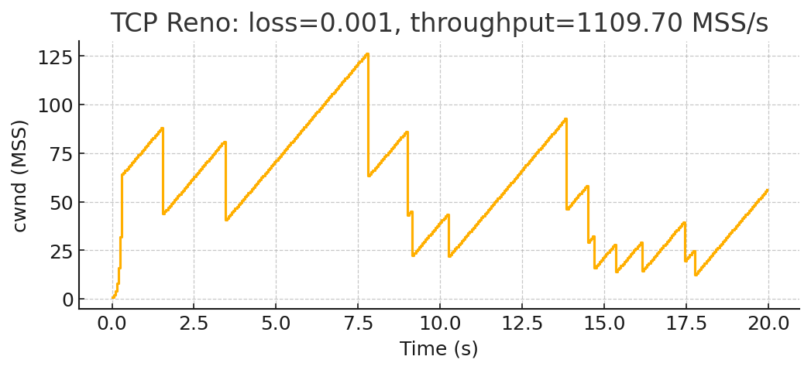

Loss Probability: 0.01
Throughput: 250.000 MSS/second
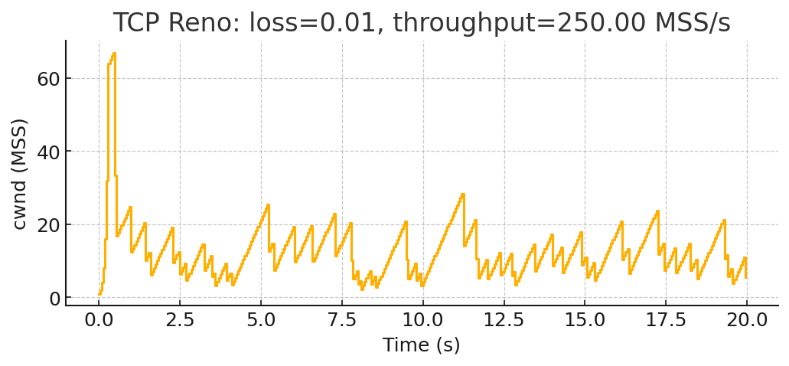

Loss Probability: 0.02
Throughput: 185.900 MSS/second
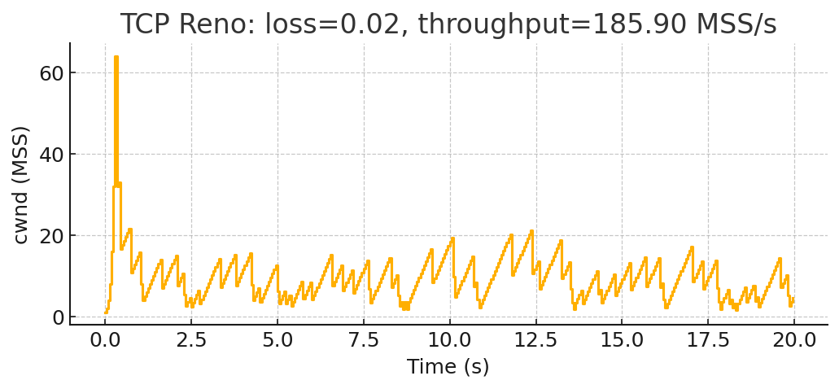

Conclusion
Conclusion:
As packet loss increases from 0.1% to 1% to 2%, TCP Reno experiences:
1. More frequent multiplicative decrease events (cwnd halving).
2. Less time spent in slow start because loss interrupts exponential growth.
3. Smaller average congestion window during congestion avoidance.
4. Throughput significantly decreases because cwnd recovers slowly after each packet loss.
Higher loss → lower throughput, more oscillations, worse performance.

